



Marketing Plan Template

You can edit your own version in one of two ways:
- Edit this version to fit your needs
- Go to “File” > “Download As” > “Microsoft Word” to Download

How to Use This Template
This template should be used as a jumping off point for your company’s marketing plan. It includes customizable sections for:
- Business Summary
- Business Initiatives
- Target Market
- Market Strategy

Once you’re ready to begin, delete pages 1–3 and start filling out your info below. There will be instructions and sample text, as well as prompts in [brackets] for you to complete as guided.

Remember, you should add/edit/delete any copy or sections as you see fit. We’ve also included an example of what this template might look like once it’s finished below the template itself.

All Your Marketing  Tools and Data – All Under One Roof.  Learn more about the value of marketing software that grows with you. |  | 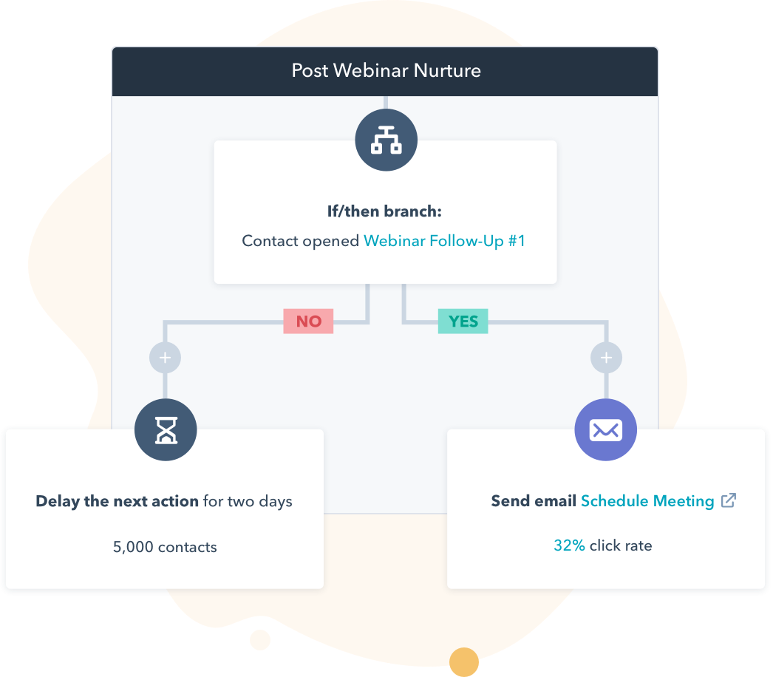
 | Get Started With Marketing Hub

Keep scrolling to templates
↓↓↓



Company Name
Marketing Plan

Our Objective | Summarize the role your company’s marketing department plays to the growth of your business. This statement should reflect your overall strategy outlined in the pages that follow.
Authors of Document | [Name #1]  [Email Address #1]  [Name #2]  [Email Address #2]

Table of Contents | Business Summary  Business Initiatives  Target Market  Market Strategy | #  #  #  #

Business Summary

Our Company
[Company name] is a company headquartered in [location of HQ] with offices in [satellite office locations]. The company’s mission is to [mission statement].

Our Marketing Leaders

[Marketing Leader 1] | [Marketing Leader 1] is [company name]’s [job title of Marketing Leader 1]. They will [brief job description of Marketing Leader 1].
[Marketing Leader 2] | [Marketing Leader 2] is [company name]’s [job title of Marketing Leader 2]. They will [brief job description of Marketing Leader 2].
[Marketing Leader 3] | [Marketing Leader 3] is [company name]’s [job title of Marketing Leader 3]. They will [brief job description of Marketing Leader 3].

  Pro Tip: | You might want to call out some of the features that make your marketing leadership team spectacular, such as education, years of experience, and specific areas of expertise. You can also include headshots.

SWOT Analysis
As [company name]’s marketing team, we want to help the brand lean into what it does well, improve what it doesn’t, capitalize on what it can do, and defend against what could challenge it. With that in mind, here is our SWOT analysis for [current year].
Strengths | Weaknesses
What we’re good at.  What’s working.  What our customers like about us. | What we want to fix.  What we want to strengthen.  What we want to become more efficient at.
[Enter strengths here] | [Enter weaknesses here]

Opportunities | Threats
What the industry might soon want.  What we think we’ll be good at.  What will be our differentiator? | What we think could hinder our growth.  What/who we think could take our customers.
[Enter opportunities here] | [Enter threats here]

Pro Tip: | Read more about how to make an excellent SWOT analysis in this blog post from Dr.Khanh

Business Initiatives

[Company name] has the ambitious goal of [overarching company goal]. To help the business do that, our marketing team will pursue the following initiatives in [current year]:

Initiative 1
Description | [Example: Over the next 12 months, we’ll work on building a blog property that becomes a go-to resource for our customers’ burning questions – and our number-one source of leads month over month.]
Goal of initiative | [Example: To increase our website’s rank on Google and create critical top-of-the-funnel marketing content that helps our sales team start more conversations with prospects.]
Metrics to measure success | [Example: 50,000 organic page views per month / 10 content downloads per month]

Initiative 2
Description | [Example: Over the next 12 months, we’ll work on building a blog property that becomes a go-to resource for our customers’ burning questions -- and our number-one source of leads month over month.]
Goal of initiative | [Example: To increase our website’s rank on Google and create critical top-of-the-funnel marketing content that helps our sales team start more conversations with prospects.]
Metrics to measure success | [Example: 50,000 organic page views per month / 10 content downloads per month]

Initiative 3
Description | [Example: Over the next 12 months, we’ll work on building a blog property that becomes a go-to resource for our customers’ burning questions -- and our number-one source of leads month over month.]
Goal of initiative | [Example: To increase our website’s rank on Google and create critical top-of-the-funnel marketing content that helps our sales team start more conversations with prospects.]
Metrics to measure success | [Example: 50,000 organic page views per month / 10 content downloads per month]

Target Market

Industries
In [current year], we’re targeting the following industries where we’ll sell our product and reach out to customers:
Industry 1 | This includes [sub-industries where your business might target more specific segments of your audience]. [Example: Industry 1: Food and Beverage. This includes bar & grills, breweries, steakhouses, etc.]

Industry 2 | This includes [sub-industries where your business might target more specific segments of your audience]. [Example: Industry 1: Food and Beverage. This includes bar & grills, breweries, steakhouses, etc.]

Buyer Personas
Within our target market(s), we’ve identified the following buyer personas to represent our ideal customers:

Buyer Persona 1 | This includes [sub-industries where your business might target more specific segments of your audience]. [Example: Industry 1: Food and Beverage. This includes bar & grills, breweries, steakhouses, etc.]

Buyer Persona 2 | This includes [sub-industries where your business might target more specific segments of your audience]. [Example: Industry 1: Food and Beverage. This includes bar & grills, breweries, steakhouses, etc.]

Competitive Analysis
Within our target market(s), we expect to compete with the following companies:

Company 1
Products we compete with | [This competitor’s product/service, what it does, and what it might do better than yours]
Other ways we compete | [Example: This competitor has a blog that ranks highly on Google for many of the same keywords we would like to write content on]

Company 2
Products we compete with | [This competitor’s product/service, what it does, and what it might do better than yours]
Other ways we compete | [Example: This competitor has a blog that ranks highly on Google for many of the same keywords we would like to write content on]

Company 3
Products we compete with | [This competitor’s product/service, what it does, and what it might do better than yours]
Other ways we compete | [Example: This competitor has a blog that ranks highly on Google for many of the same keywords we would like to write content on]

Pro Tip: | You can use these Competitve Analysis Templates to conduct more thorough research on your competitors.

Market Strategy

Product
[Describe the products with which you will enter the target market described in the section above. How will this product solve the challenges described in your buyer persona description(s)? What makes this product different from (or at least competitive against) your competition?]

Price
[How much are you selling this product for? Is it competitive? Realistic for your customers’ budget? Will you run any seasonal promotions/discounts associated with this product?]

Promotion
[How will you promote this product? Think more deeply than your blog or social media channels. What about this content will drive value into your product?]

People
[Who in the marketing department plays a role in your market strategy? Describe what each of them, or each team, will do to bring your market strategy success.]

Process
[How will the product be delivered to your customer? Is it an ongoing service? How will you support their success with your product?]

Physical Evidence
[Where is your product displayed? If you sell an intangible product, how would customers produce visible evidence of your business?]

Marketing Plan Example  Need some inspiration? We took the liberty of filling out the template for a mock company. Feel free to take some pointers! | 

Keep scrolling to the example
↓↓↓



San Diegency

Marketing Plan Example

Our Objective | To delight and attract businesses in the greater San Diego area with the promise of excellent and unbeatable agency services.
Authors of Document | Alex Smith  asmith@sandiegency.com  Serena Li  sli@sandiegency.com


Table of Contents | Business Summary  Business Initiatives  Target Market  Market Strategy

Business Summary

Our Company
San Diegency is a San Diego-based marketing agency. We offer full marketing services and exist to offer unparalleled marketing work to businesses in San Diego and neighboring areas.
Our mission is to empower San Diego organizations to effectively communicate with current and potential stakeholders.

Our Marketing Leaders
 | Naman Malik is San Diegency’s CEO. He started the agency in 2014 and holds his MBA with a concentration in Marketing and Entrepreneurship from USC.  Naman was born and raised in San Diego. His mother owned a small business, which inspired him to help other local organizations thrive.
 | Serena Li is San Diegency’s CMO. She has a decade of experience in digital marketing with specialties in content marketing, SEO, PR, and PPC campaigns.  Serena joined the agency in 2019 and holds a BSBA from UCLA.
 | Alex Smith is San Diegency’s Director of Demand Generation. Alex manages the agency’s organic acquisition and content marketing teams.  Alex worked in journalism for 20 years before transitioning to marketing. He holds a Bachelor’s Degree from Emerson College in Boston, MA.

SWOT Analysis
As San Diegency’s marketing team, we want to help the brand lean into what it does well, improve what it doesn’t, capitalize on what it can do, and defend against what could challenge it. With that in mind, here is our SWOT analysis for this year.
Strengths | Weaknesses
- Talent. SD has 80 full-time employees dedicated to serving San Diego businesses.  - Customer base. Our agency serves some of the area’s largest, most influential orgs. | - Lack of specialization. At our core, our services are identical to other agencies’.  - Low profit margins. Due to competition, we need to keep our prices low.

Opportunities | Threats
- Demand for digital. There is a growing demand for digital marketing services in SD.  - Growing population. As SD’s population grows, so does the amount of businesses. | - Competition. There are at least 12 other major San Diego area agencies, plus nationwide ones.  - Slow business growth. Orgs are still struggling to recover from the economic downturn.

Business Initiatives

San Diegency has the ambitious goal of acquiring 24 new customers and retaining 80% of its existing customer base this year. To help the business do that, our marketing team will pursue the following initiatives.

Initiative 1: Invest in Account-Based Marketing
Description | San Diegency has found significant success with organic and paid search campaigns, but we have yet to dedicate resources to targeted, account-based initiatives. To do this, we will hire three dedicated AMB reps.
Goal of initiative | Appeal to larger, higher-volume clients who want a personalized pitch and approach.
Metrics to measure success | 10 accounts acquired exclusively through account-based marketing campaigns.

Initiative 2: Explode our Online Presence
Description | To build upon our existing online success, we need to invest resources into strategically growing our online presence as well as turning a profit on contacts acquired through these efforts.
Goal of initiative | Through a combination of paid campaigns, new content campaigns, and exploring new online groups, we can tap into new personas and appeal to more potential clients.
Metrics to measure success | Double our organic traffic numbers and paid ad leads.

Initiative 3: Become San Diego’s Webinar Destination
Description | One area we have yet to pursue is webinars. We know people are craving online content, community, and education, and San Diegency is in a position to provide that to businesses.
Goal of initiative | Produce a minimum of six webinars to bring in new leads, engage with existing clients, and provide tactical and topical information to help San Diego businesses thrive.
Metrics to measure success | 3,000 webinar registrants (500 each session)  50 new QLs.

Target Market

Industries
This year, we’re targeting the following industries where we’ll sell our product and reach out to customers:
 | Restaurants  San Diego’s restaurant and brewery scene continues to grow, and these businesses are pivoting due to a rise in demand for delivery and off-premise dining.

 | Schools and Universities  With more than 150 schools and universities in San Diego, these educational hubs are an untapped market – particularly private institutes and colleges.

Buyer Personas
Within our target market(s), we’ve identified the following buyer personas to represent our ideal customers:

 | Chef/Owner Charlotte  Charlotte is a restaurant owner aged in her early 30s. She’s unmarried but is committed to her business. She worries about keeping her restaurant sustained and is skeptical about off-premise dining habits.

 | Dean Daniel  Daniel is the head of advancement for his school. He wants to keep enrollment numbers high and donation numbers higher. He’s in his 50s, married, and is proud to work at his school.

Competitive Analysis
Within our target markets, we expect to compete with the following companies:

Nation’s Marketing Agency
How we compete | Nation’s offers the same services as we do, but with the resources, size, and affordability of a nationwide agency.
How we can win | We live and breathe San Diego. We can offer more personalized services to our target audience.

California Marketing Brothers
How we compete | CMB’s services are identical to ours, with the exception of video. They also appeal to our audience.
How we can win | We once again benefit from hyper-localized work, and we offer video services which CMB does not.

Duff and Sandler Agency Services
How we compete | D&S is another San Diego-based agency with multiple connections. They pose a direct competition to us.
How we can win | The agency is still small and new, so we have a comparative first mover advantage and a larger amount of people and resources to win clients over.

Market Strategy

Product
San Diegency is a full digital marketing agency, offering expert support and services in all of the following areas:
- Content Marketing.
- SEO.
- Paid Marketing Campaigns.
- Video Production.
- Graphic Design.
- Website Development.
- General Marketing Strategy.
Our services provide a range of options for businesses and organizations of all size and experience. We’re happy to work with for-profit and nonprofit, private and public, large and small businesses alike.

Price
Our price range varies by business type, size, and need. We craft specific packages based on the impact our work will have on our clients’ bottom lines, the amount of output our team will produce, and the administrative and research billable hours our team will undertake. Packages start at $3,000 minimum but can go as high as six figures for ongoing, high-impact projects.

Promotion
We promote our services in the following ways:

- Organic channels, such as our website and our blog.
- Paid campaigns on social media and search engines for targeted business owners in San Diego.
- Webinars – our newest investment to speak to prospects, customers, and new contacts alike.
- Communal integration and working with local institutions for volunteering and sponsorship opportunities.
This strategy combines paid, personal, and organic opportunities to reach new customers and engage existing ones.

People
Our Marketing Team has 28 individuals sitting under three teams. We have specialists in demand gen, events, brand, and social eager to help our company reach new heights.
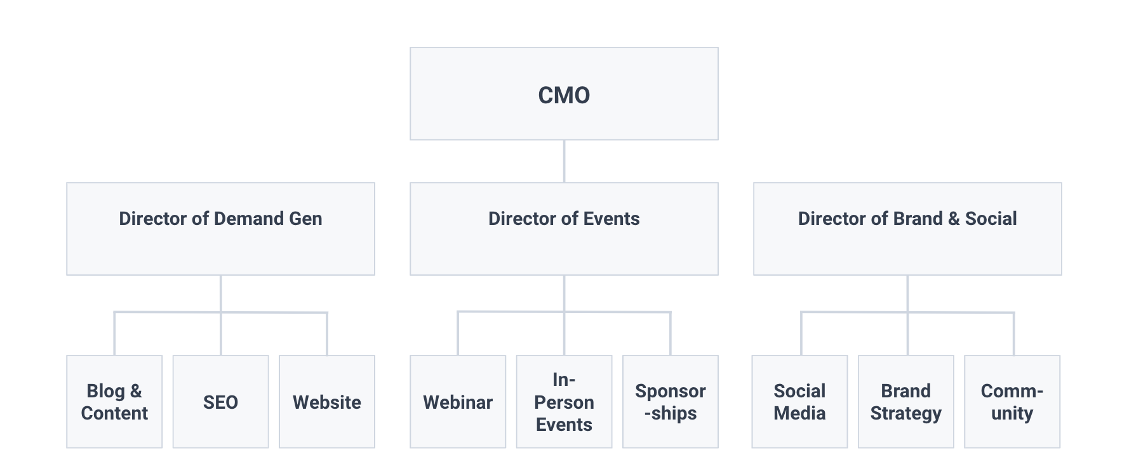

Process
Due to our sprint approach, our process will look different for all customers. Clients will receive any and all services they are interested in, and we will work with them on a timeline that best suits their needs and budget.

